Image | 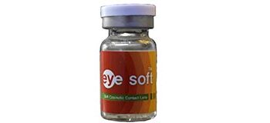
Brand | DIOR
Model Name | EYE SOFT TORIC
Price | RS 4500
PRODUCT DETAILS

